Title: Identity Quilt - The Complexities of Ethnic Identity

Overview ⎸ Preparation ⎸ Lesson Procedure ⎸ Evaluation

Overview
Lesson Overview | At the beginning of the school year, it is important to connect with students. In the complex world of identity, it is important to empower students through Primary Sources to identify and understand their ethnicity and other aspects of identity.  During this unit of study, we will explore the meaning of identity vocabulary for a culturally and linguistically diverse classroom. The final assessment is for the students to complete an identity square that is made into a classroom quilt.
Author(s) & School | Originally created by Christina Ireland, Sunset Middle School, Longmont, CO; modified by Marjorie Mcintosh
Grade Level/  Course | Middle School level (6,7,8)  Lesson can be adapted to fit any grade level
Standards | - WIDA Can do Descriptors by Language Domain - Listening, Oral Language, Speaking, Reading, and Writing K-12  - CDE Standard Oral Expression and Listening 6.1.d Engage effectively in a range of collaborative discussions (one-on-one, in groups, and teacher-led) with diverse partners on grade 6 topics, texts, and issues, building on others’ ideas and expressing their own clearly. (CCSS: SL.6.1)  - CDE Reading for all purposes 6.2.c Use Integration of Knowledge and Ideas to: i. Integrate information presented in different media or formats (e.g., visually, quantitatively) as well as in words to develop a coherent  understanding of a topic or issue. (CCSS: RI.6.7)  - Colorado English Language Proficiency Standards - ELLs communicate information, ideas, and concepts necessary for academic success in the content area of Language Arts.
Time Required | Multi Class, 3-4 class periods
Topic | Culture/identity issues
Time Period | 2000 - present
Tags (keywords) | Identity, language, Hispanic, Latino/a, Chicano/s, Chicanx, Xicano/a, indigena, bilingual, gender, inclusivity, affirming, social language, teaching tolerance, education, Primary Sources

Preparation (Links to worksheets, primary sources and other materials):
Materials | - 5 x 5 white paper squares for rough draft sketches  - 5 x 5 fabric squares (white)  - Fabric for quilt (any color) - size depends on the class size  - Fabric scissors  - Fabric glue  - Fabric paint
Resources/Links | Terms and Visual Materials:  *Hispanic vs Latino  *What’s in a Name? Jeopardy “Game” with Jason Romero  Video of game  Resources/Links:  *Identity: The Power of Language  *Poem - I am Latino Pride by Janie Garcia
Resources from a specific community | Three videos of young Latinos/as discussing identity issues in 2013:  Dalia Sanchez, Longmont High School - https://www.youtube.com/watch?v=7eS3B9swnrk&feature=youtu.be  Kelly Sarceno, Skyline High School, Longmont - https://www.youtube.com/watch?v=HHUjNIGSnh8&feature=youtu.be  Jason Romero, CU Boulder (after HS and junior college in Pueblo) - https://www.youtube.com/watch?v=3aSHWktzPcY&feature=youtu.be

Lesson Procedure (Step by Step Instructions):
Preview of Unit on Identity
- Begin by giving students a slip of paper. Ask them to write an ethnic word that describes them, such as “Mexican.”
- Collect papers, fold, and put in a hat (sombrero).
- Give each student 3 sticky notes labeled: 1 - Like me, 2 - Not like me, 3 - Unsure
- Teacher will pull a piece of paper with an ethnic term out of the hat. Students will use their sticky notes to show how well each term fits their own identity.
*option for movement - Have three posters on the wall in different places:
(LIKE ME, NOT LIKE ME, I DON’T KNOW)
When you read the ethnic words out of the hat, have students stand near the poster that identifies how they feel about each label.
Option Lesson if all ELL students are of Latino descent:
- Warm up -Graphic organizer - Fold a paper in fourths. Title each square (Hispanic, Latino/a, Chicano/a, Indigenous)
- Have students write their version/definition of those terms. Discuss.
- Show video clip on the History of “Hispanic vs Latino” https://www.youtube.com/watch?v=GBt5rMD2aDc
- Exit ticket - Ask students about one new vocabulary word from the video and class discussion.
Optional Homework - Have students interview a parent or community member on identity. Ask parent what word they use to identify with (Collecting interviews to use as Primary Sources for other activities exploring identity). Bring in family photos to share.

Lesson 1:
1. Warm up - Graphic Organizer (from - Facing History and Ourselves )
Have students draw their hand on a blank piece of paper. Write 10 words that you use to
identify yourself. Examples: Bilingual, teacher, mother, etc.).
2. Have the student write identity terms outside of their hands on how they believe other
people see them. Circle the words that are inside and outside of the hand.
3. Question/Answer
4. Read the Poem together as a class - “I am Latino Pride” by Janie Garcia
Think - Pair- Share - What did you learn about the author? What were the identity words used in the poem?
Lesson 2: This is an opportunity for a teacher to find primary sources from their own community and to have students bring in photos and stories from their own families and neighborhoods
- Watch 3 video clips of young people discussing their identities Three videos of young Latinos/as discussing identity issues in 2013 (above, under Primary Sources)
- Dalia Sanchez and Kelly Sarceno
- Discussion - What kind of identity issues did these students face?
Lesson 3:
- Warm up - Identity Acronym Poem (C - Chicano, H - Hispanic, R - Religious Identity, S - Silly)
- Give students a 5x5 piece of paper. Have them sketch the name that they most identify with along with a symbol such as a Mexican/American flag (rough draft).
- Final copy - Give students a 5 x 5 cut piece of fabric (quilt square) to decorate with fabric paint.
- Place Fabric squares on fabric wall; use either fabric glue or sew on wall/quilt.
- Project Rubric - Quilt Square (see Evaluation/Assessment)
Lesson 4:
- Game of Jeopardy - Groups of 4
- What’s in a Name? Jeopardy with Jason Romero
Optional Lessons - Using Primary Sources - Collecting immigrant stories from your community and sharing with your class or bringing in guest speakers to share about their identity stories.

Evaluation/Assessment: (Methods for collecting evidence of student learning)
- Project Rubric - Quilt square http://rubistar.4teachers.org/index.php?screen=PrintRubric&rubric_id=2632835&
- Short Constructed Response - “What did you learn about Identity?” Use 6+1 Trait Writing Rubric - http://rubistar.4teachers.org/index.php?screen=ShowRubric&rubric_id=2747884

Extension Lesson #1-
Purpose: Students will write an essay expressing the identity term they used to describe himself. Explain the origin of the term, what it means, and how you are connected to the vocabulary word.
- Ethnic term
- What the term means
- Why you identify with the ethnic term
- Explain the symbol you used to express your word
Writing Rubric - 6+1 Trait Writing Model: What Did you Learn About Your Identity?
Using Rubistar http://rubistar.4teachers.org/index.php?screen=ShowRubric&rubric_id=2747884
Extension Lesson #2- https://www.facinghistory.org/resource-library/my-part-story-exploring-identity-united-states/finding-your-voice
Facing History and Ourselves
- Finding Your Voice Connecting to the Past
- Identity and labels Many Voices, One National Identity

Students can earn this badge for successful completion of the lesson.

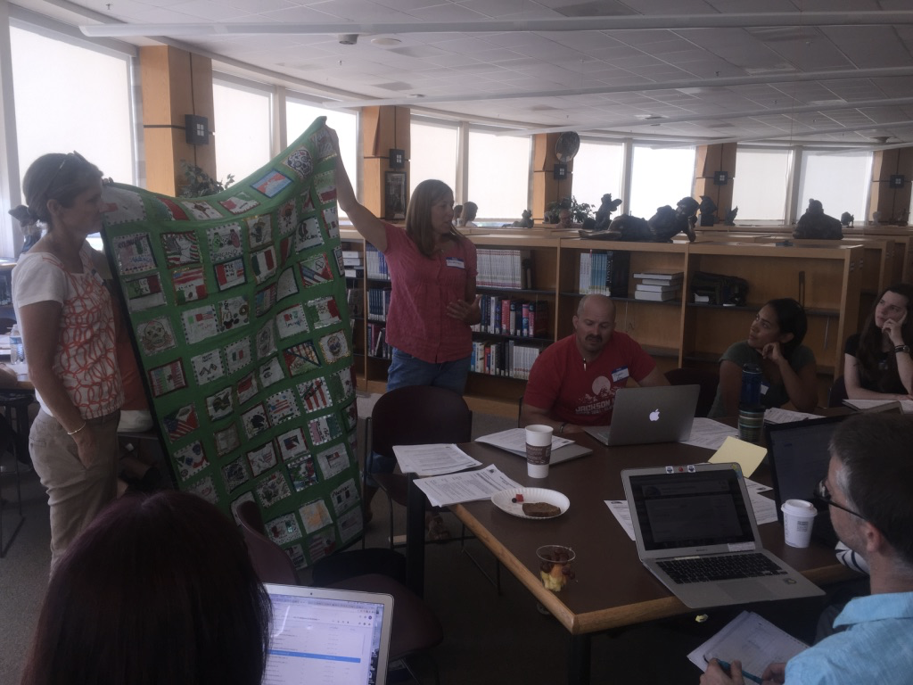
Displaying a sample identity quilt at a teacher workshop, 2017

Prepared by the Latino History Project, 2017-18 